**NIGHTS WATCH**

**USER MANUAL**

Version 1.0

December 2017

TABLE OF CONTENTS

1. INTRODUCTION 3

1.1 About Nights Watch 3

2. User Guide 3

2.1 Django Installation 3

2.2 Functionalities 4

3. ROLES 10

3.1 ADMIN 10

3.2 USER 10

4.Team Members and Email Id 10

1. INTRODUCTION

* 1. About Nights Watch

Nights Watch is a web portal that receives and displays data from the sensors. The sensor data would be overlaid on a map with other data such as weather information. The user would use the portal to display different representations of the data in the form of graphs and text files. Additionally, the web system would need the administrative capability to added new sensors. The user in the field would likely use a phone to register the new sensor to a location.

1. USER GUIDE
   1. Django installations
2. To install Django follow the instructions mentioned in - <https://docs.djangoproject.com/en/1.11/topics/install/>
3. Install the following dependencies :

pip install django-rest-framework-social-oauth2

pip install social-auth-app-django

pip install django-oauth-toolkit

pip install python-cors-header

pip install pillow

python manage.py migrate

pip install pyowm

if you do not have pip you will need to install/upgrade pip instructions can be found here - <https://pip.pypa.io/en/stable/installing/>

1. Copy the project code and paste it to a location.
2. Navigate to the folder which contains manage.py.
3. Run python manage.py makemigrations.
4. Run python manage.py migrate
5. To obtain sensor information simply open a terminal [windows navigate to the folder where you hve saved particle.py , open a terminal there and run the command - python particle.py ; you will need to have python installed for information on how to install python visit the link - <https://www.python.org/downloads/>].
6. To run the website on linux server
7. You need an account on the linux server.
8. Transfer the files on the server.
9. Create a Screen on terminal using the command:

>>screen –s projectname

1. To enter the screen, use

>> screen –x projectname

1. If you already have a screen running, you can view it at

>>screen –ls

1. After entering the screen, you should follow the above mentioned steps, from 1 to 7
2. To exit the screen, and keep the environment working. Close the terminal directly without stopping the execution.
   1. Functionalities:

We have already set up every thing assuming the current set up was used , launch the site from : <http://silo.soic.indiana.edu:545401>.

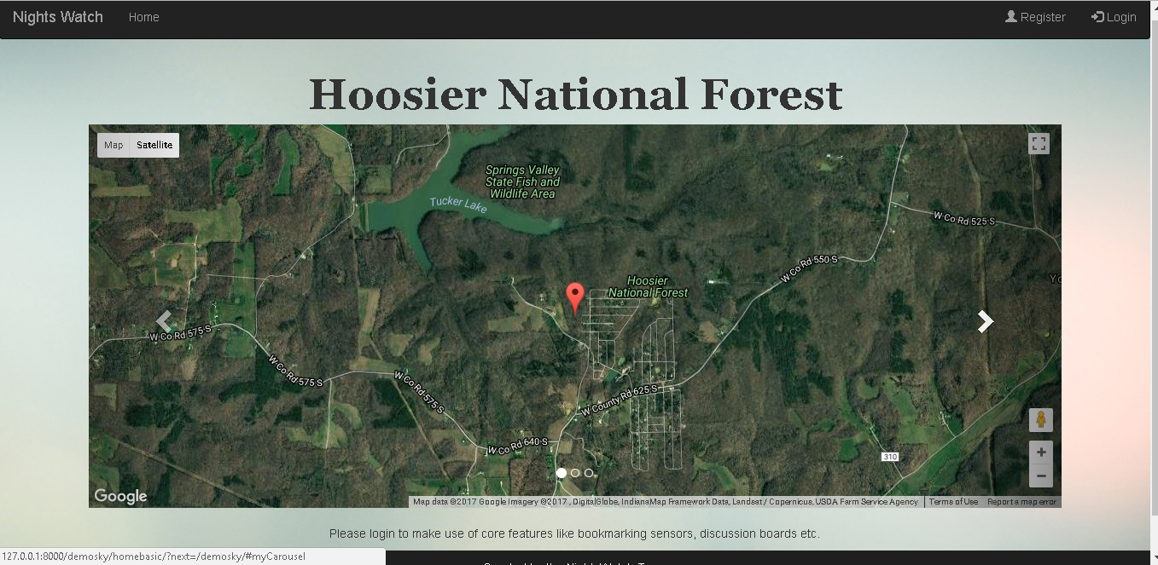

For a new user there are multiple ways to login the traditional username , email ,password

or log in via facebook account or login via gmail . Follow the latest oauth2 protocols and ensure secure login added to that is our own token verification mechanism.

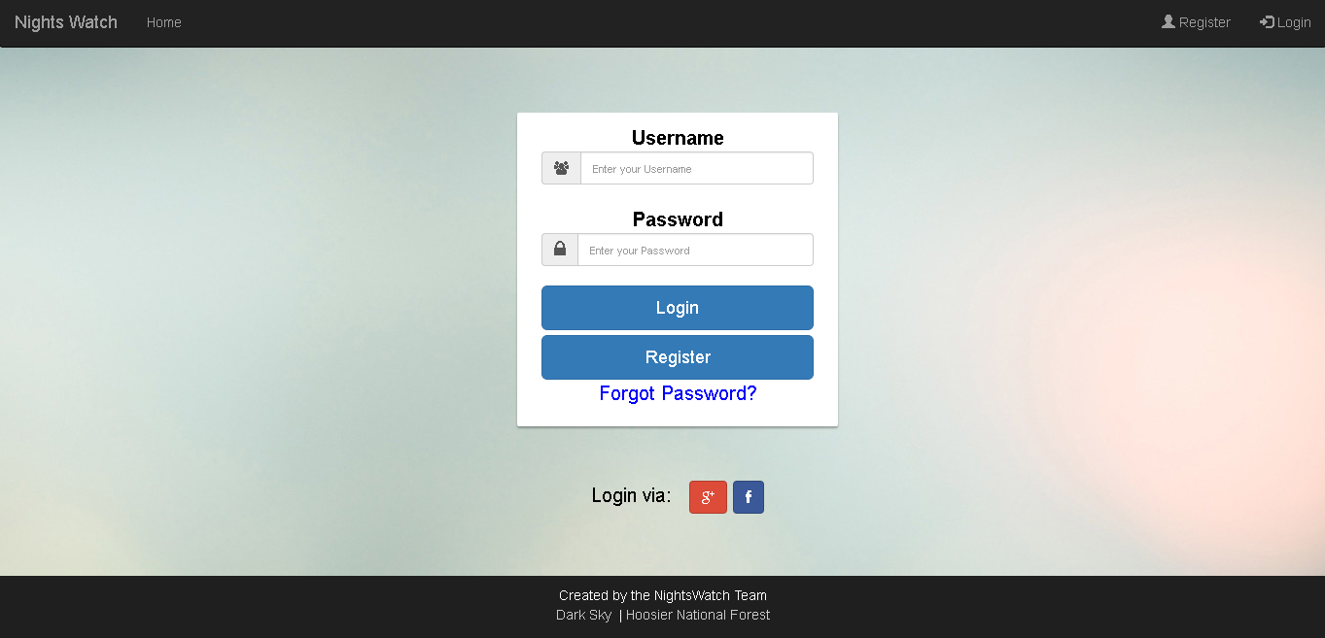

Token Validation:

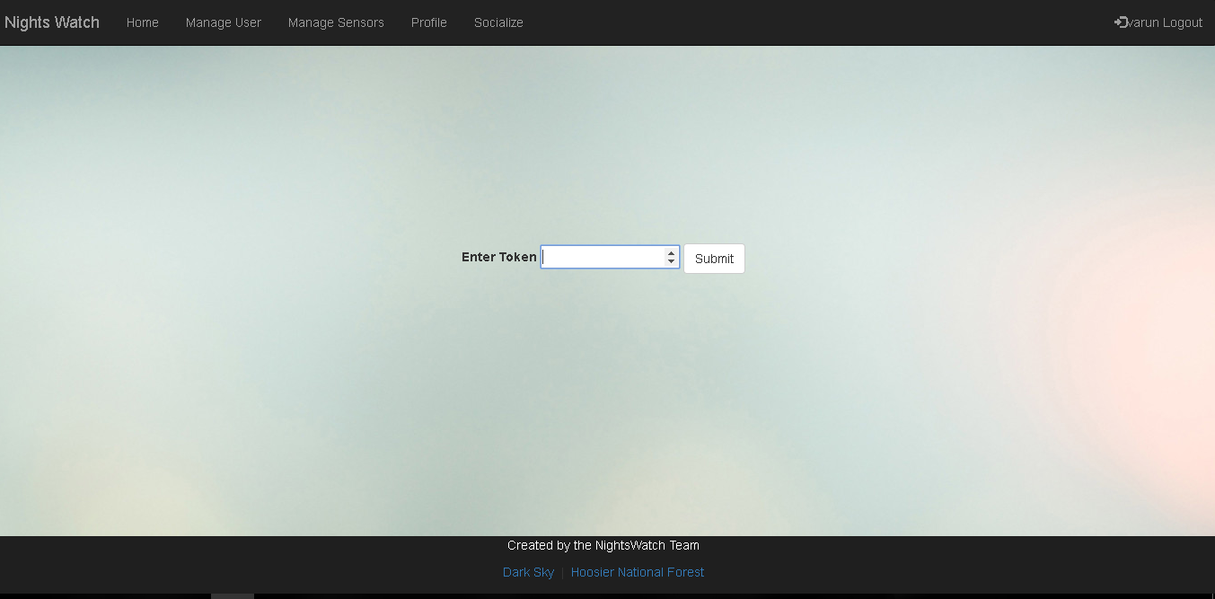

On logging in the user will be directed to the homepage , here he can select from a list of available sensors from the dropdown, which will then center the map accordingly. Clicking on a sensor on the map will reveal useful information about the sensor like its coordinates charge level , light intensity , images of the sensor have to be placed in the images folder of static.

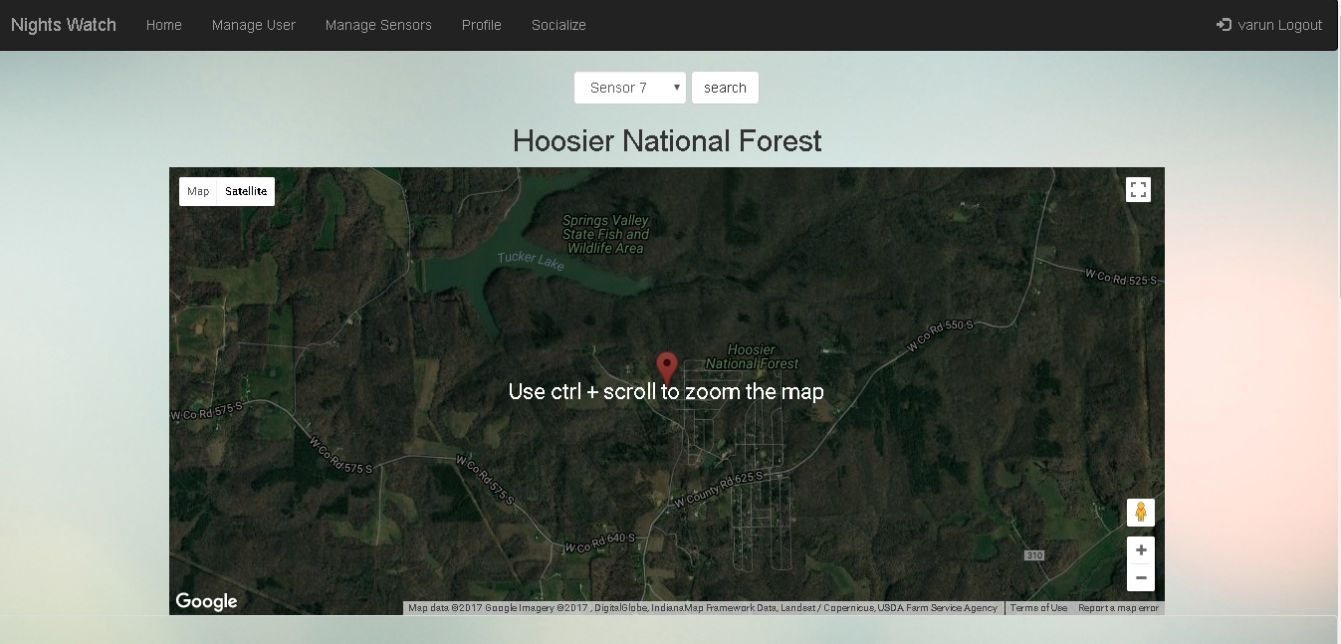

There is also an option to bookmark sensors.

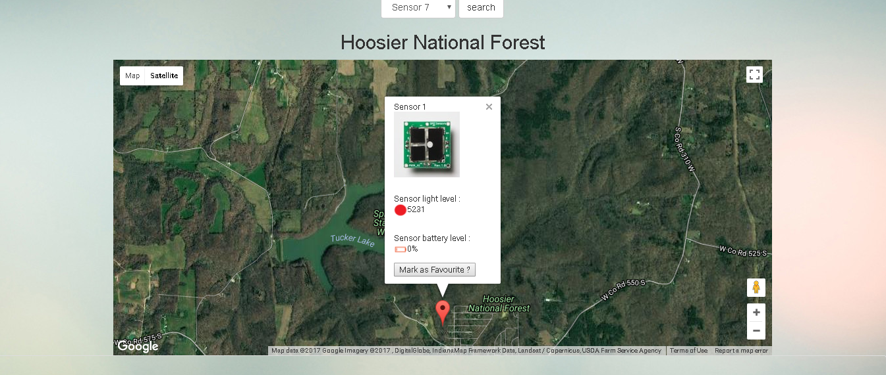

Below the map a handy representation of light intensity , weather widget and graphs on the light intensity can be found.

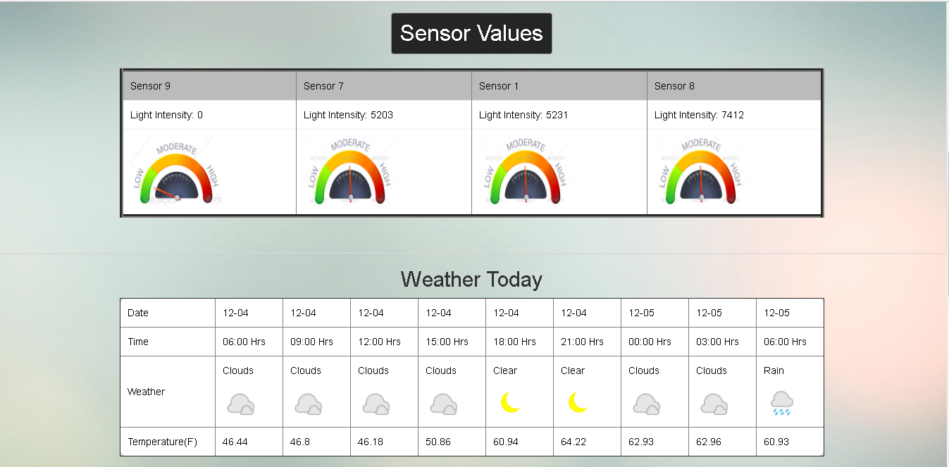

Hourly view of the sensor details:

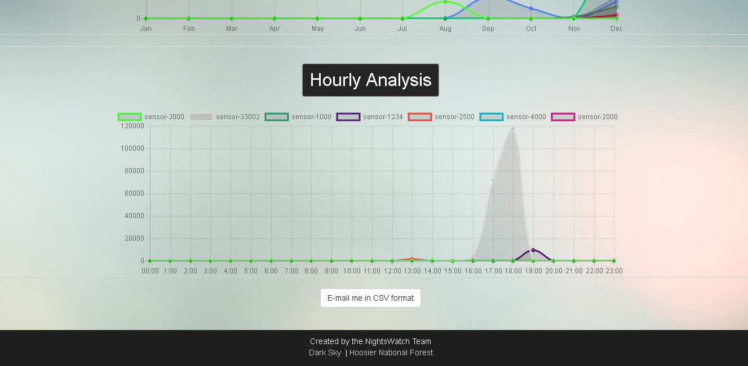

A user can be promoted to an admin via the manage user page

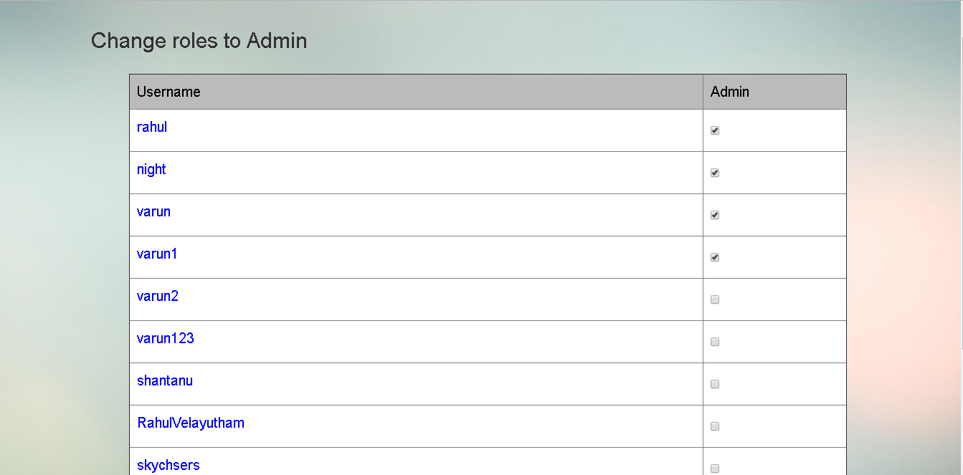

Sensors can be managed via the manage sensor page. By default sensors can be "added" to the database only by particle.py admins can then choose whether or not to "promote" these sensors to display on the map. Provisions have been made to change the coordinates and delete sensors altogether.

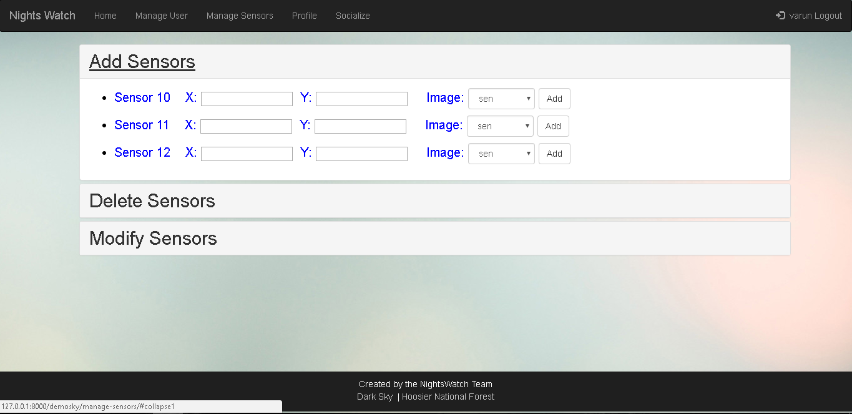

The profile page tab allows the user to create a profile which will be useful to express his tastes so that other users can view this profile and plans can be made.

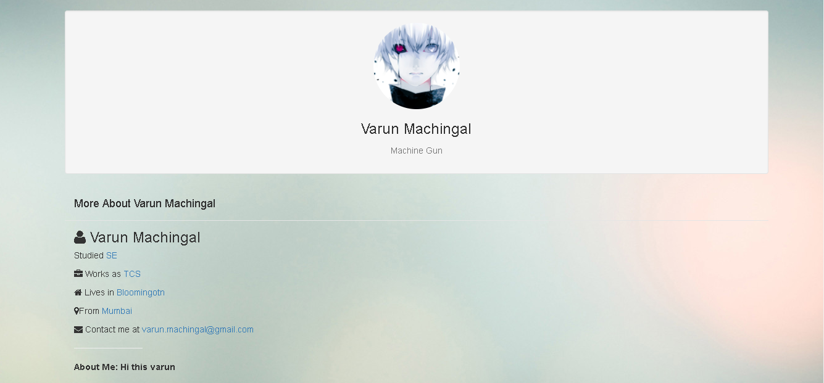

The socialize tab allows users to search users either by username or keys. In the top right we have create a discussion board and a general purpose chatroom.

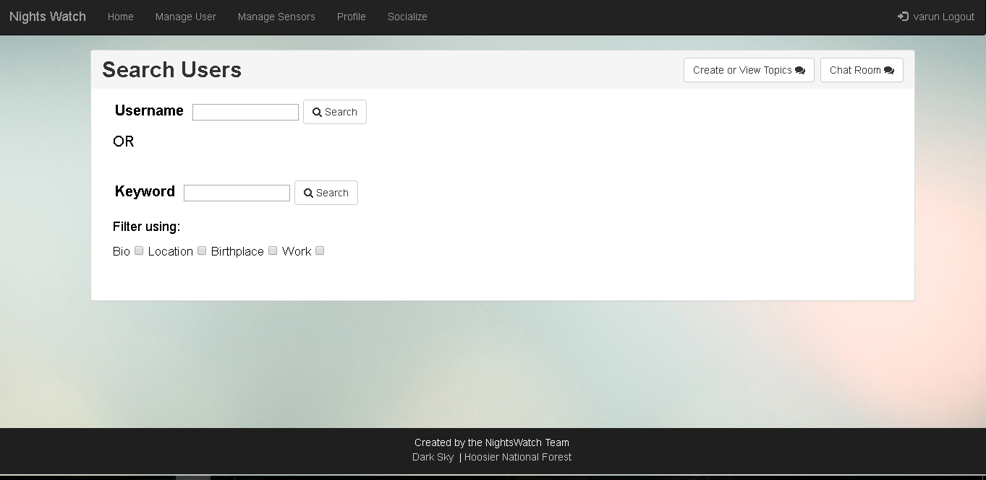

The discussion board can be used for any discussion varying from notifying an admin about something to planning a hiking trip.

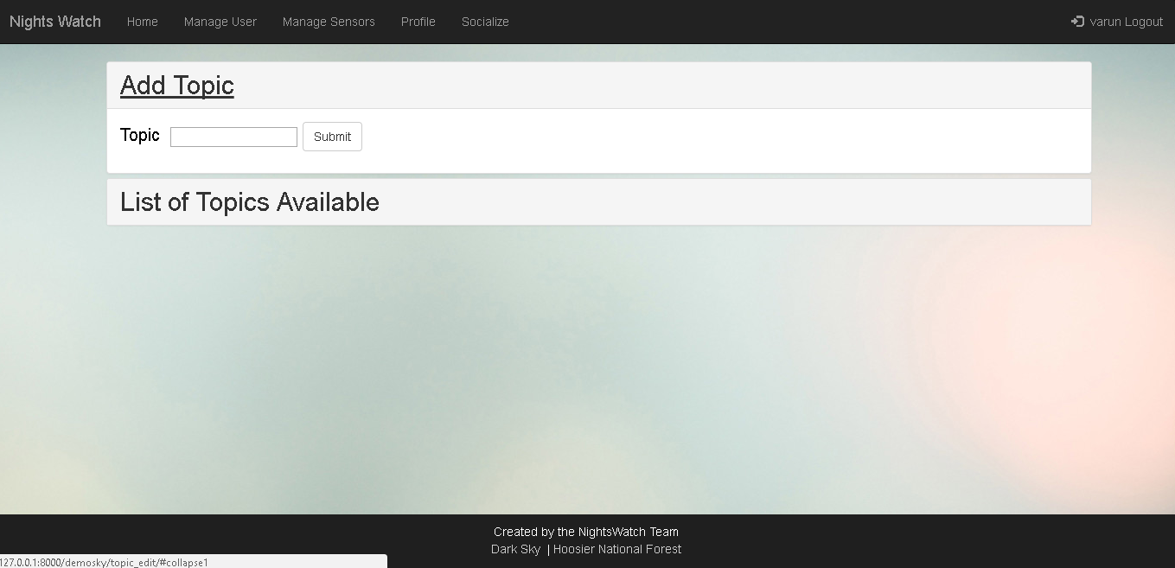

A chat room exists to talk to users in real time

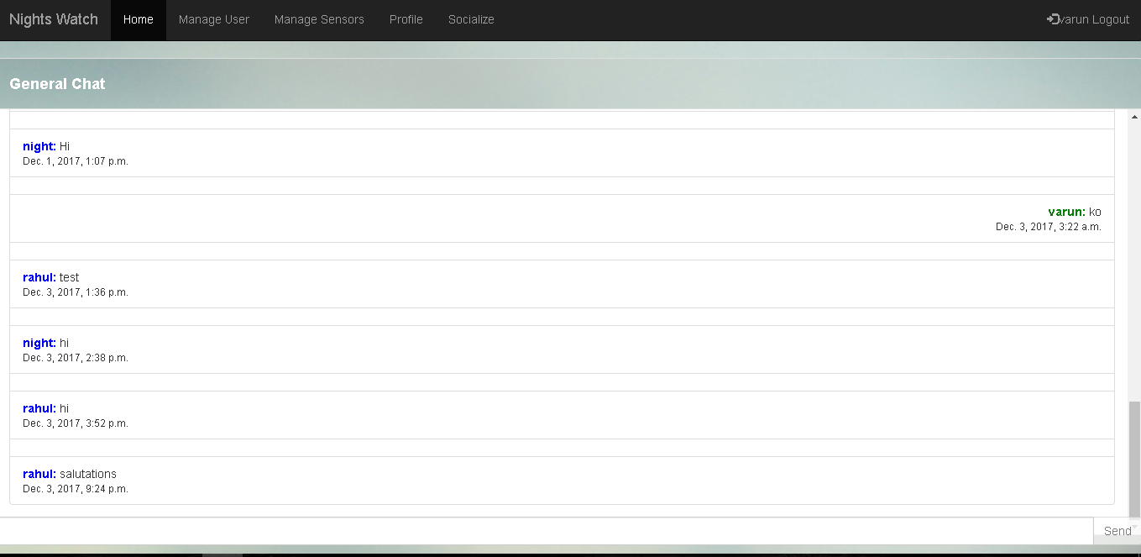

1. Roles
   1. ADMIN

Only the admin has the right to change a user’s role. He can promote a user role to admin or change an admin to a normal user. But there always has to be one admin present at all times. The admin can add, delete and modify sensors coordinates from the manage-sensors tab.

* 1. User

The user can only view the map and view the sensor details from the map. The normal user does not have access to manage-sensor and manage-user tabs. The user can view other users profile and can chat with other users on the socialize tab.

1. Team Members and Email ID

Varun Machingal - [vmaching@iu.edu](mailto:vmaching@iu.edu)

Rahul Velayutham - [rahuvela@umail.iu.edu](mailto:rahuvela@umail.iu.edu)

Adarsh Bhandary - [adnbhand@umail.iu.edu](mailto:adnbhand@umail.iu.edu)

Shantanu Kotambkar - skotambk@iu.edu